Digital Forensics Investigation
NIST CFReDS 2015 Data Leakage Case
Cue Patrick Khan | June 2026

Project Overview
This document presents the findings from a complete digital forensics investigation conducted on the NIST CFReDS 2015 Data Leakage Case, a publicly available forensic challenge produced by the National Institute of Standards and Technology (NIST). The investigation involved the systematic examination of a Windows 7 forensic disk image and two removable media images to reconstruct the actions of a suspected corporate insider who exfiltrated confidential data.
The investigation applied industry-standard forensic methodology: evidence acquisition with hash verification, artifact extraction, registry analysis, browser forensics, cloud storage examination, file system analysis, and anti-forensics identification. Findings were corroborated across multiple independent artifact sources to establish a reliable evidentiary chain.

Case Background
The suspect, operating under the account name "informant", is alleged to have stolen confidential [secret_project] files from a corporate workstation. The investigation sought to determine what data was taken, by what method, and to reconstruct the suspect's timeline of activity prior to their apprehension.

Evidence Item | Description
PC Disk Image | cfreds_2015_data_leakage_pc.dd, Windows 7 Ultimate SP1 workstation
Removable Media #1 (RM#1) | exFAT filesystem, 3818MB, volume label: "Authorized USB"
Removable Media #2 (RM#2) | FAT32 filesystem, 1024MB, volume label: "IAMAN $\_@"
Device Hash (SHA-1) | F07632FAA66A47088DEB07BDB45CC568E4BF650B

Tools Used
Tool | Purpose
FTK Imager | Forensic image mounting, registry hive export, file extraction, hash verification
Autopsy | File system analysis, keyword search, deleted file recovery, timeline analysis
Registry Explorer | Windows registry hive parsing — SOFTWARE, SYSTEM, SAM, NTUSER.DAT
DB Browser for SQLite | Query Chrome browsing databases and Google Drive sync databases

Investigation Screenshots

System Information: SOFTWARE Hive (Registry Explorer)
The SOFTWARE registry hive was exported from the PC image using FTK Imager and loaded into Registry Explorer. Navigating to SOFTWARE\Microsoft\Windows NT\CurrentVersion revealed the OS product name (Windows 7 Ultimate), version (6.1), install date (Unix timestamp 1427034866 = March 22, 2015), and registered owner ("informant"), confirming the suspect's identity and OS installation date.

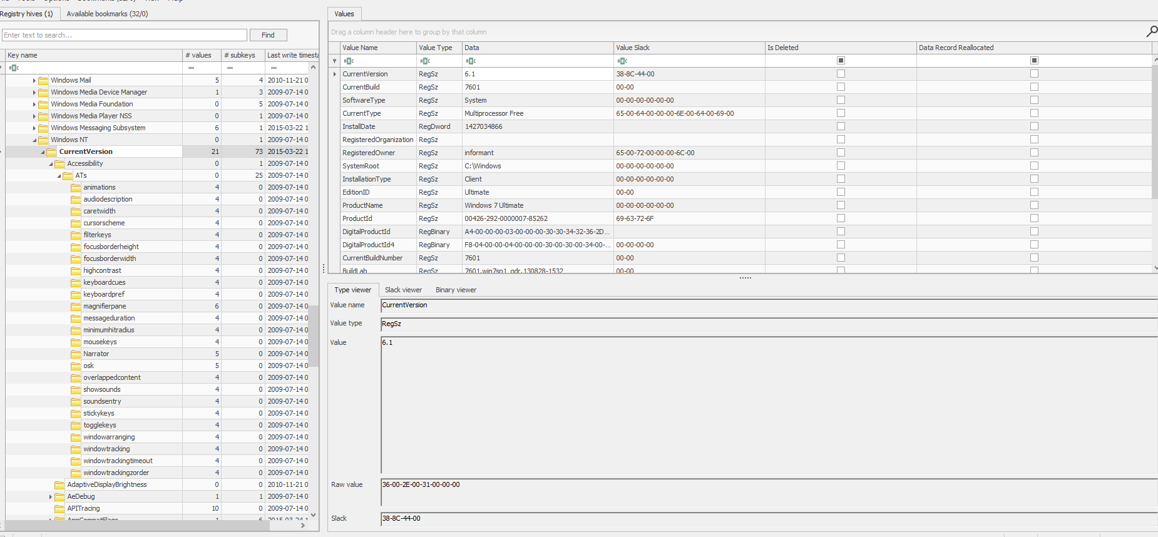
Figure 1- Registry Explorer: SOFTWARE hive showing OS version, install date, and registered owner 'informant'

User Account Enumeration: SAM Hive (Registry Explorer)
The SAM hive was loaded to enumerate all user accounts on the workstation. Under SAM\Domains\Account\Users\Names, four non-default accounts were identified: admin11, Administrator, Guest, informant, ITechTeam, and temporary. The presence of multiple accounts indicates a shared or managed workstation environment, with "informant" being the primary suspect account.
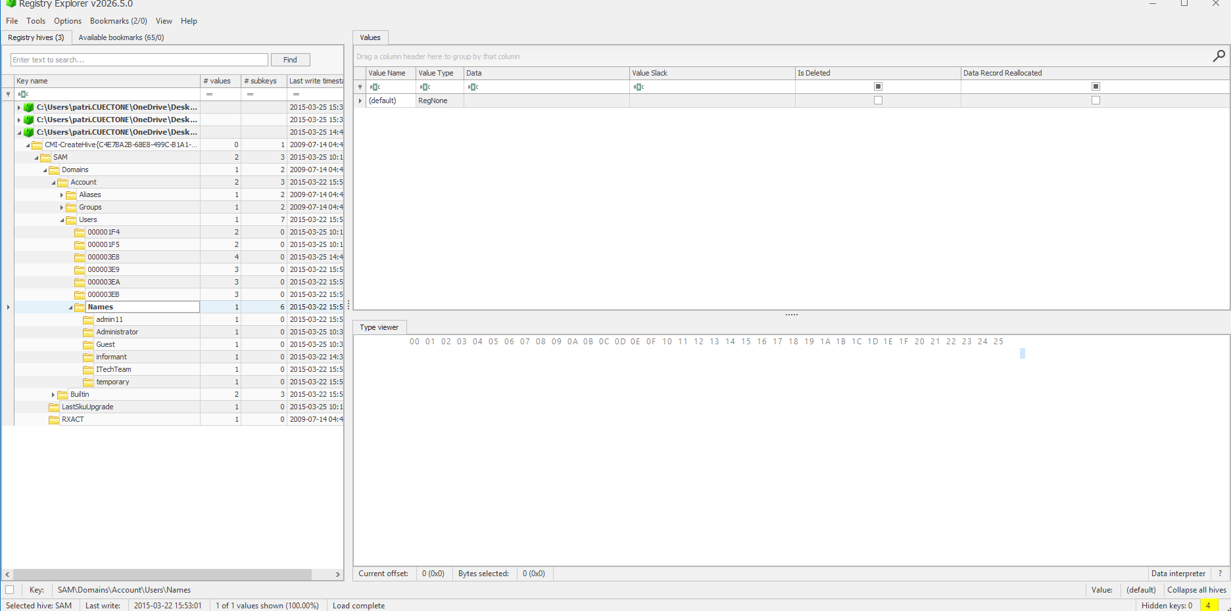
Figure 2- Registry Explorer: SAM hive showing all user accounts including 'informant'

Browser Activity: Chrome History (DB Browser for SQLite)
The Chrome History database was opened in DB Browser for SQLite and queried using a SQL statement converting Chrome's proprietary timestamp format to readable UTC times. Results confirmed the suspect searched for "data leakage methods", "leaking confidential information", and "information leakage cases" on March 23, 2015, the same day the [secret_project] files were copied to USB. Earlier activity on March 22 showed the suspect switching from Internet Explorer to Chrome.

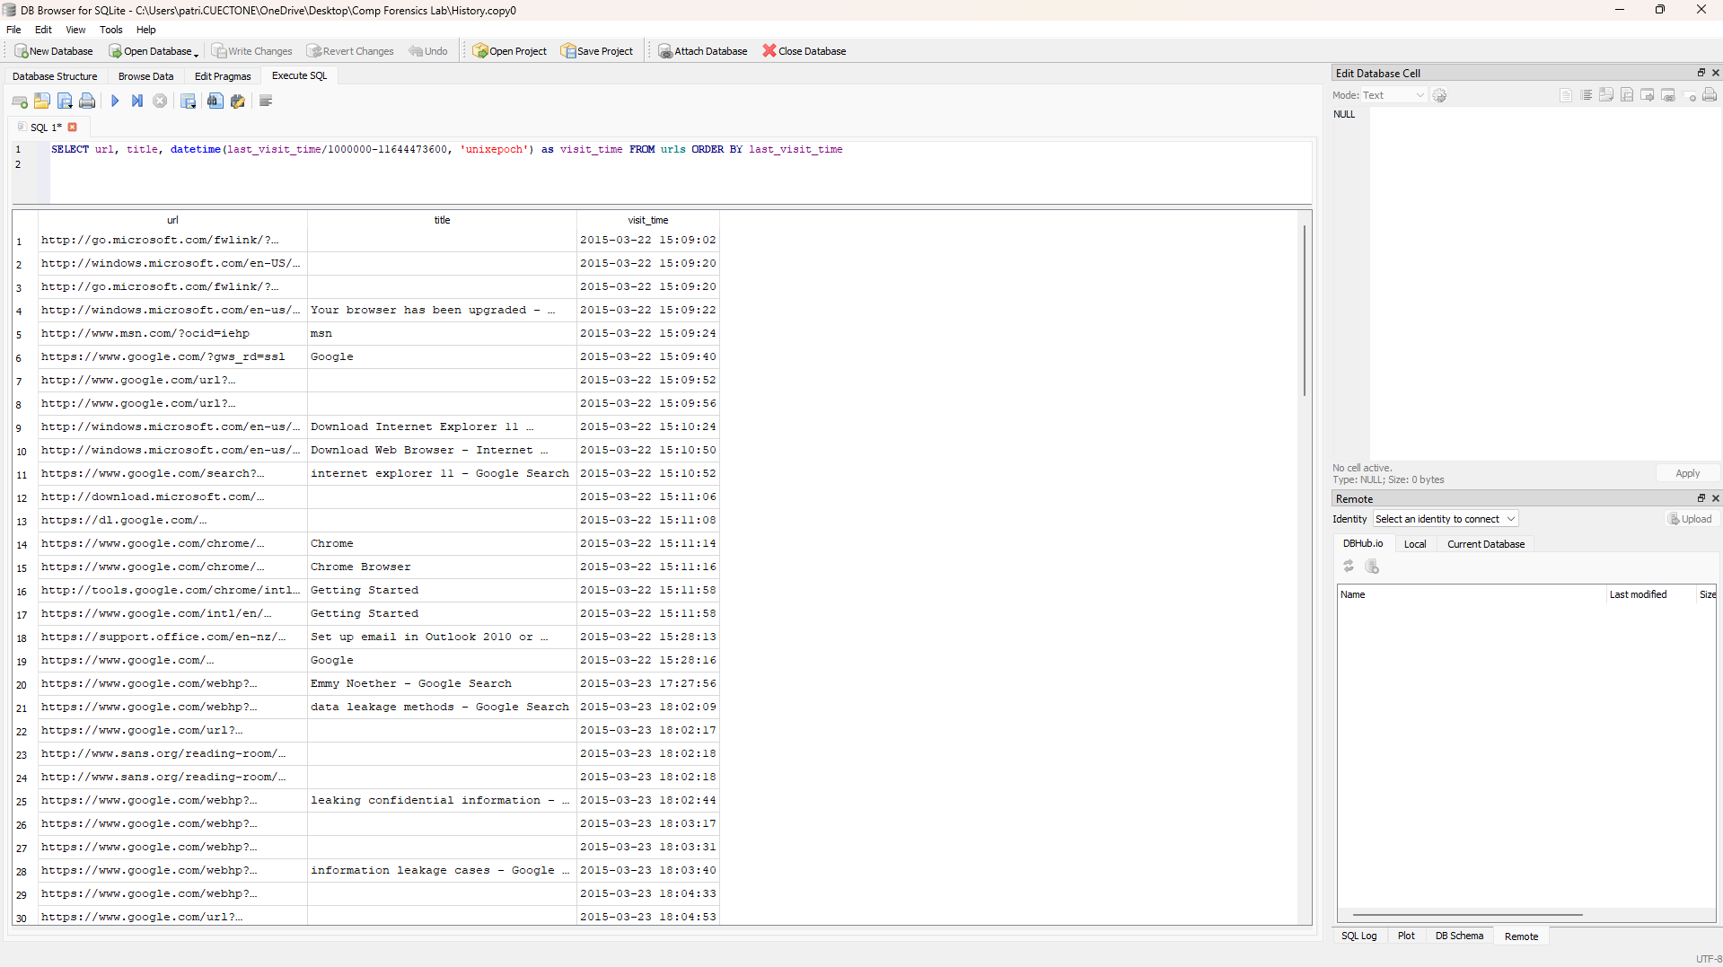
Figure 3- DB Browser for SQLite: Chrome History query showing browsing activity including data leakage searches on March 23, 2015

Recent Documents: NTUSER.DAT RecentDocs (Registry Explorer)
The NTUSER.DAT hive's RecentDocs key under Software\Microsoft\Windows\CurrentVersion\Explorer\RecentDocs was examined. The results panel shows 30 total rows of recently accessed files, including [secret_project]_proposal.docx, [secret_project]_design_concept.ppt, [secret_project]_final_meeting.pptx, [secret_project]_pricing_decision.xlsx, pricing decision, secret, and the Resignation_Letter_(Iaman_Informant) in both .docx and .xps formats — providing a comprehensive record of the files the suspect accessed prior to apprehension.

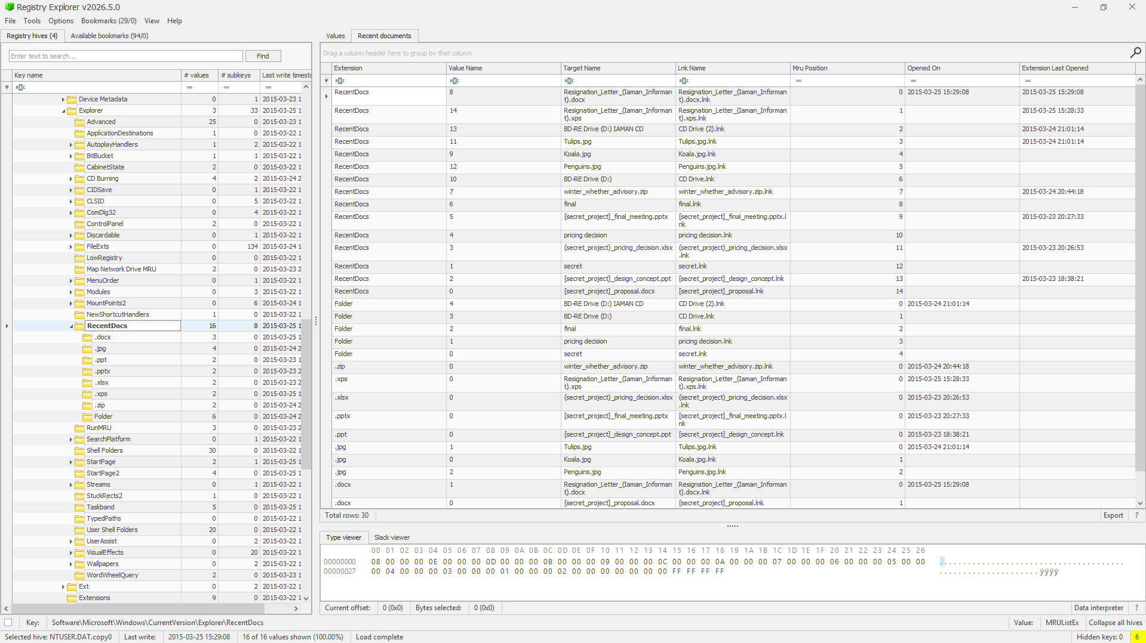
Figure 4- Registry Explorer: NTUSER.DAT RecentDocs showing secret_project files and resignation letter accessed by the suspect

Cloud Storage Anti-Forensics: Google Drive (FTK Imager)
FTK Imager was used to navigate to Users\informant\AppData\Local\Google\Drive\user_default\. The file listing reveals snapshot.db, sync_config.db, and their associated .shm and .wal write-ahead log files, all with file sizes indicating they had been emptied. The hex panel at the bottom confirms the file contents consist entirely of null bytes, confirming deliberate wiping of all Google Drive sync records as an anti-forensic measure.

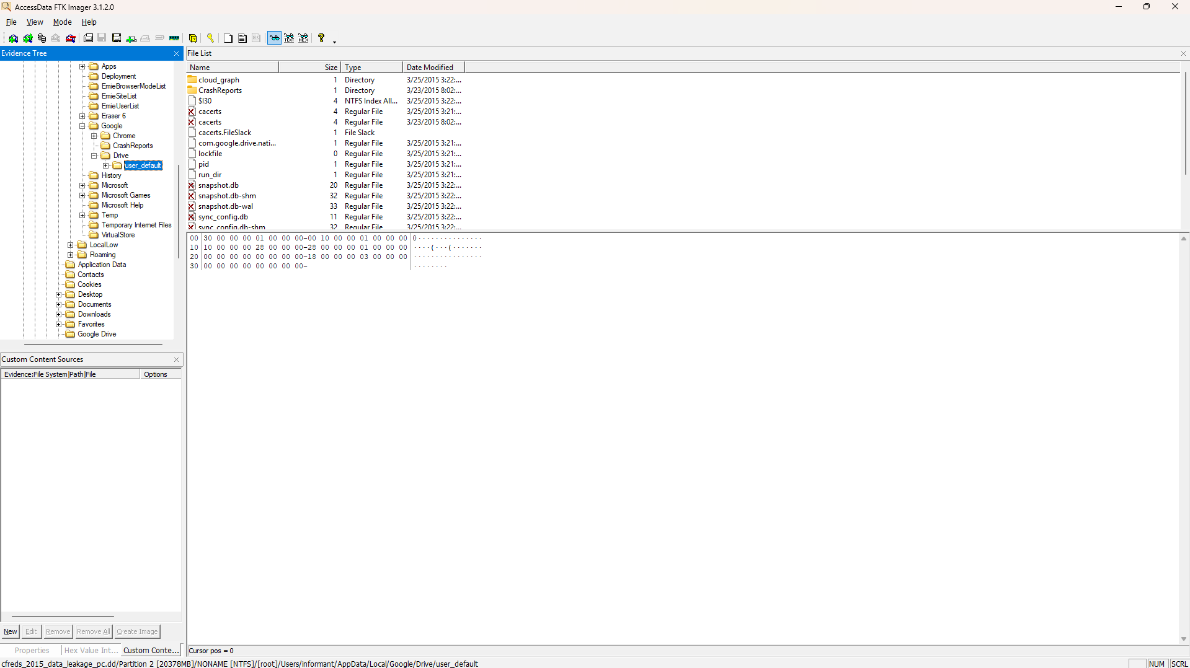
Figure 5- FTK Imager: Google Drive user_default folder showing snapshot.db and sync_config.db wiped (null byte contents confirmed in hex panel)

Removable Media Analysis: RM#1 Authorized USB (FTK Imager)
FTK Imager was used to mount cfreds_2015_data_leakage_rm#1.E01. The evidence tree shows the exFAT partition (3818MB) with volume label "Authorized USB" containing the root folder with RM#1 and Secret Project Data directories. The hex panel confirms the volume label string — displaying "Authorized USB" in the readable ASCII column — and further down shows the strings "A-Secret-Project-Data" confirming the folder contents. This directly corroborates the LNK file evidence from the PC image.

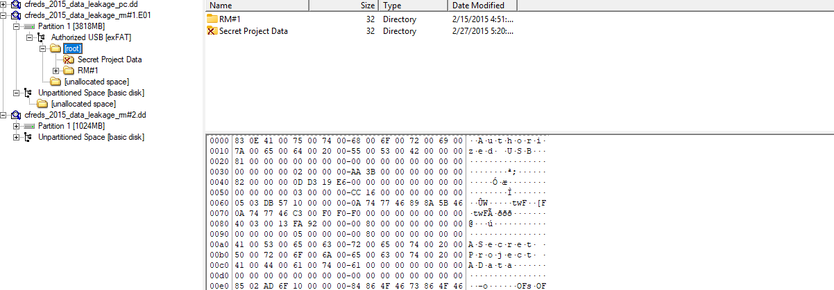
Figure 6- FTK Imager: RM#1 exFAT partition showing Secret Project Data folder with hex panel confirming 'Authorized USB' volume label string

System & Configuration Findings
Artifact | Finding | Source
OS Name | Windows 7 Ultimate SP1 | SOFTWARE\Microsoft\Windows NT\CurrentVersion
OS Install Date | March 22, 2015 | InstallDate DWORD (Unix timestamp 1427034866)
Timezone | Eastern Standard Time (UTC-5) | SYSTEM\CurrentControlSet\Control\TimeZoneInformation
Last System Shutdown | March 25, 2015 at 15:31:05 UTC | SYSTEM hive
DHCP-Assigned IP | 10.11.11.129 | SYSTEM hive- network interface configuration
Last Logged-on User | informant | SAM hive
Non-default User Accounts | 6 accounts identified (admin11, Administrator, Guest, informant, ITechTeam, temporary) | SAM hive
Windows Explorer Search Term | "secret"- suspect searched locally for project files | NTUSER.DAT

File Exfiltration- USB Evidence

LNK File Analysis
LNK files in Users\informant\AppData\Roaming\Microsoft\Windows\Recent\ confirmed the files copied to USB and established the precise time of exfiltration. The NTUSER.DAT RecentDocs key corroborated these findings with timestamps and file extension groupings.
LNK File | Timestamp | Target | Significance
[secret_project]_design... | 3/23/2015 06:38 | Secret Project design file | Copied to USB: matches RM#1 design subfolder
[secret_project]_proposal... | 3/23/2015 06:37 | Secret Project proposal file | Copied to USB: matches RM#1 proposal subfolder
[secret_project]_final_... | 3/23/2015 08:27 | Secret Project final version | Final document exfiltrated same morning
secret.lnk | 3/23/2015 06:38 | "Authorized USB" (in hex strings) | Directly links PC files to RM#1 USB drive
pricing decision.lnk | 3/23/2015 08:26 | Pricing decision document | Additional confidential document accessed
Resignation_Letter_(Ia... | 3/25/2015 03:28-03:29 | Two versions of waiver letter | Created on last day before apprehension

Removable Media Comparison
Attribute | RM#1- Authorized USB | RM#2- IAMAN $\_@
Filesystem | exFAT | FAT32
Partition Size | 3818 MB | 1024 MB
Volume Label | Authorized USB | IAMAN $\_@
Visible Files | Active Secret Project Data folders (design, proposal) | Empty root directory — no visible files
Deleted Content | None recovered | Deleted FAT32 directory entry remnants in unallocated space
Key Finding | Confirmed destination of [secret_project] files | Deliberate file deletion confirmed via unallocated space

Cloud Storage- Google Drive
Database File | Finding
snapshot.db | Found empty / wiped- null byte contents confirmed in hex view
sync_config.db | Found empty / wiped- null byte contents confirmed in hex view
dict_2.db | Found empty / wiped- metadata records destroyed

Anti-Forensic Actions Identified
Action | Tool / Method | Evidence | Date
File wiping | Eraser 6 | Found in installed apps; logs and task list cleared | March 24, 2015
Evidence cleanup | CCleaner | Found in installed applications | Undetermined
Cloud sync records destroyed | Manual DB wipe | Google Drive .db files emptied (null bytes confirmed) | Before March 25
Print queue cleared | Manual deletion | Physical spool folder empty after printing | March 25, 2015
USB files deleted | Manual deletion | RM#2 — deleted FAT32 entries in unallocated space | Before apprehension
CD burned and removed | Windows burner | Burning executable in Recycle Bin; no CD image on PC | March 24, 2015

Reconstructed Activity Timeline
Date | Time (approx.) | Activity
March 22, 2015 | ~15:09 | Windows OS installed; Chrome downloaded and installed
March 23, 2015 | 06:37 – 08:27 | [secret_project] files copied from network drive to USB (RM#1)
March 23, 2015 | 18:02 – 18:04 | Suspect searched for 'data leakage methods' and 'leaking confidential information' in Chrome
March 24, 2015 | - | CD burned with project files; CD physically removed
March 24, 2015 | - | Eraser 6 used to wipe files; Recycle Bin items deleted
March 24, 2015 | - | Resignation letter created
March 25, 2015 | 03:28 | Resignation letter printed via XPS; print queue cleared
March 25, 2015 | 15:31 UTC | Final system shutdown- suspect apprehended at security checkpoint

Skills Demonstrated
Skill | Applied Through
Forensic image acquisition & integrity | SHA-1 hash verification on PC image before analysis
Windows registry forensics | SOFTWARE, SYSTEM, SAM, NTUSER.DAT hive analysis via Registry Explorer
Browser forensics | Chrome History queried via SQL in DB Browser for SQLite; timestamps converted from Chrome epoch format
Cloud storage forensics | Google Drive .db files examined; null-byte wiping confirmed in hex view
File system forensics | NTFS LNK files, Recycle Bin artifacts, NTFS timestamps analysed
Removable media analysis | exFAT and FAT32 volumes compared; deleted FAT32 entries recovered from unallocated space
Anti-forensics identification | Eraser 6, CCleaner, DB wiping, print queue clearing all documented with evidence
Timeline reconstruction | Correlated artifacts across registry, browser history, LNK files, Recycle Bin, and removable media
Forensic tool proficiency | FTK Imager, Autopsy, Registry Explorer, DB Browser for SQLite

